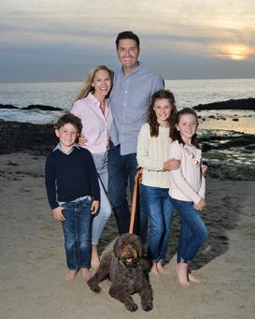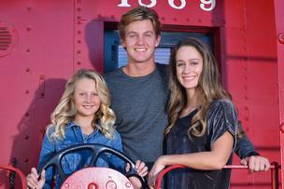  San Juan Children’s Education Foundation  Holiday Photo Fundraiser  Photography Studio – Accent Portraits by Diana will be offering a fundraiser for our school with her for a photo session for $45 that includes a 5x7 photo. You will receive a mini session of your choice at the following locations.  Please contact info@accentportraitsbydiana.com or 949-661-6465 to book your date and time and make payment for your session. Proceeds from the event will benefit your child’s grade outdoor science school account.  For questions, please contact Annya Bush – bushy4@cox.net. | Locations  - Tuesday December 3rd - Mission SJC - 3:00-4:00 pm - Must call for details for this location  - Friday December 6th - Aliso Creek beach - 3:00-4:30 pm  - Saturday December 7th - Reata Park, SJC - 11:00-12:30 pm  - Sunday – December 8th Pines Park 1:30-3:00  - Call for other locations and days

